
Ek circuit se dusre circuit ko jodne ke liye
for safety purpose
Jab circuit short hota hai to fuse burn ho jata hai.

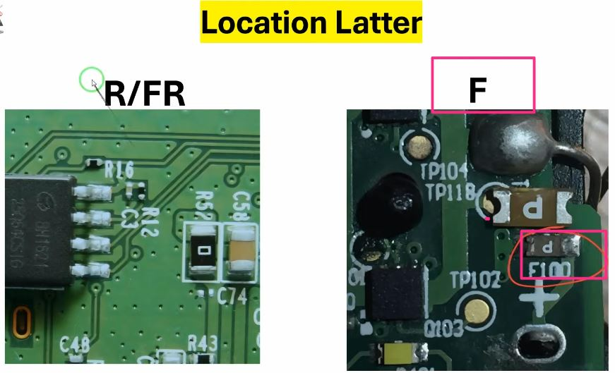
Note 1- 10 ohm resistor Fuse hi hote hai.
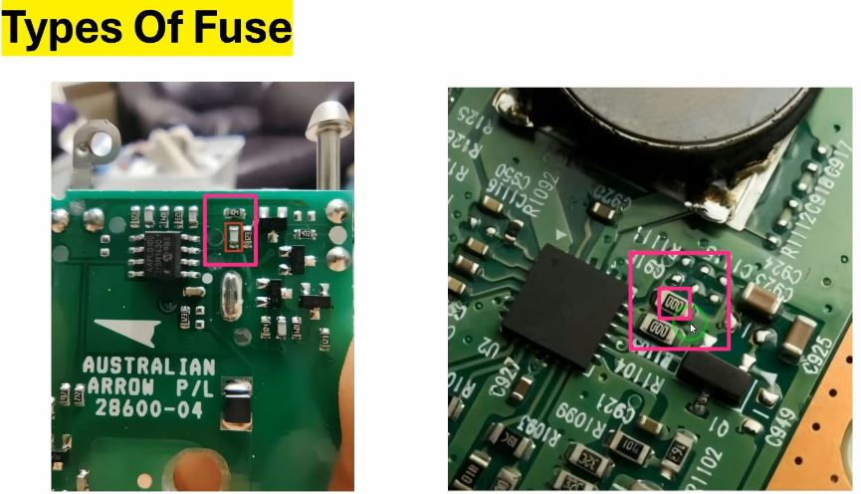
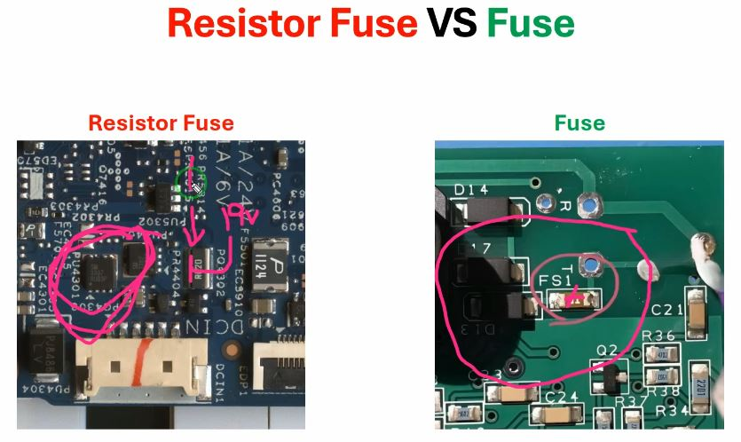
Short hone par apni value ko high kr deta hai

Bad Condition
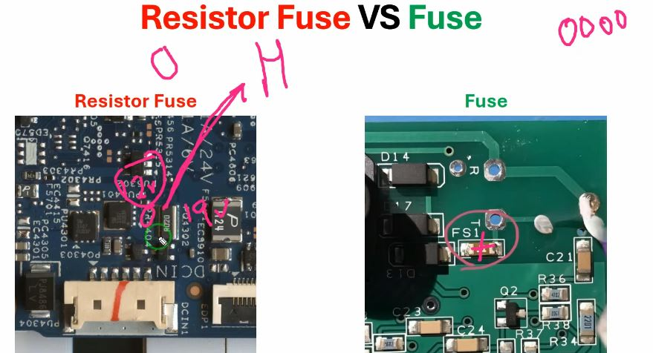
Resistor Fuse apni value(200, 1k) badha deta hai jis se voltage drop hoti hai.

